Unit Plan: Design and Technologies
Australian Curriculum  Design and Technologies | “Evaluating Equipment” |  |  |  | Years 3 and 4
Design and Technologies Knowledge and Understanding  Investigate the suitability of materials, systems, components, tools and equipment for a range of purposes (ACTDEK013) |  |  | Design and Technologies Processes and Production Skills  Evaluate design ideas, processes and solutions based on criteria for success developed with guidance and including care for the environment (ACTDEP017)
Cross-curriculum Priorities  - Sustainability |  |  | General Capabilities  - Critical and Creative thinking
Key Ideas
Design Thinking
Overview  This unit plan will teach students about suitable materials and use in products and technologies, as well as the sustainability of these products. Students learn about different materials and their features, making judgements about the appropriateness and sustainability.  Students then will use this knowledge to evaluate inventions and technologies, using a criterion that looks at many different elements. Students will then write an analysis of the product, suggesting changes so the product fits within the criterion.  In this unit, students will engage in critical analysis, applying their learnt knowledge through practical discussion and completing class activities. |  | Prior Knowledge  Commencing this unit, it is important to assess the students’ prior knowledge, and ensure students have sufficient understanding to commence this unit.  Students should have basic knowledge about:  - Common building/production materials such as different types of plastics, metal, wood, glass, paper, fabric, etc.  - Working independently with some teacher scaffolding and support.  If the students lack this knowledge, it should be taught before the commencement of the lesson. |  | Learning Outcomes  By the end of this unit, students should be able to analyse and identify the effectiveness of the materials used in a variety of technologies.  Students will develop critical thinking and analysis skills, as well as linking these skills with practical and everyday situations.  Students will have a thorough knowledge of sustainability, sustainable practices, and how to be sustainable citizens. They will be able to transfer these skills to being the citizens of the future.
Formative Assessment Tasks  Throughout this unit, formative assessment tasks will inform the teacher of the students’ understanding, informing the teacher of progress, and how to approach the next lesson, and whether additional teaching is required.  - By the end of the first lesson, students should be able to independently identify features of, and materials commonly used in inventions and technologies by matching their names to their features. Students should also be able to recall basic facts about the materials’ strengths and weaknesses.  - By the end of the second lesson, students should be able to match appropriate materials with machines, technologies, or inventions that they would be effective with, as well as identifying features and characteristics of machines, technologies, and inventions.  - By the end of the third lesson, students should be able to evaluate inventions, based on their functional qualities, aesthetic qualities, sustainability, and waste. Students should also be able to simply theorise how a machine, invention, or technology can be improved, based on its features. |  |  | Summative Assessment Piece  The summative assessment piece is the final task to be completed by students, and will be marked and reported on.  This task is an extension on the activities completed in class, though this is completed individually.  Students will be given a basic invention with many obvious flaws. Students will evaluate it, using the same sheet used in class. The students will then circle elements that should be improved to benefit the invention. Students will be required to write notes about how each element can be improved, to adhere to the evaluation sheet (such as changing the material, removing unnecessary features, make the invention more sustainable by improving the quality). Students should then perform another evaluation, based on their changes.  Full and mostly correct completion of this task will achieve full marks (or an ‘A’).  A basic standard achievement would be demonstrated through completing the evaluation, and circling the features that can be altered or changed, with no further progression on how they could be changed, or any of the following steps.
Pedagogical Approaches  The lessons in this unit will predominantly consist of explicit teaching, and class discussion, with students sharing ideas, and teacher scaffolding and support when needed.  As the students achieve mastery, they will move towards independence.  As this unit involves complex information, breaking information into chunks, or basic tasks will help student engagement and understanding.  Linking the knowledge back to the real word will help students to engage with the tasks, especially when engaging with higher-order thinking skills. |  |  | Differentiation  Within all classrooms, a range of diverse learning needs exist. It is important to cater for these learning needs to give students the best possible chance at success.  While these learning needs greatly vary, and cannot be covered in a single generic unit plan, some ideas, activities, and strategies are listed to help support, and give basic ideas  For higher achieving students:  - After completing the tasks, the students can extend their thinking, to assessing and adding to the inventions, creating strengths and developing ideas.  - Students could design other technologies to achieve the same purpose, and compare and evaluate theirs, compared to the initial invention.  For lower achieving students:  - Break up the tasks into singular learning experiences  - Create a word wall with definitions with all the words and phrases used  - Have information presented and displayed in a variety of ways, such as on an IWB, verbally, on printed handouts for students who want it, and using interactive activities. These strategies will help students to engage with the task, giving the student the most chance at succeeding  - Altering the product and work that the student completes may help the student to present the correct information, in a more simple form  - Being flexible in how the student completes the work would help the student to display their knowledge and understanding through an individual, unique method that suits the student’s needs.
Resources
- Interactive Whiteboard
- Class set of evaluation sheet
- Examples of a range of materials
  - Glass
  - Wood
  - Cardboard
  - Metal
  - Plastic
  - Fabric
  - Paper
- Pictures for a range of inventions and technologies, both effective and ineffective
- Whiteboard and pens

Lesson Overview
- Introduce students to the unit. Introduce students to the range of materials that could be used for inventions and technology. Brainstorm their features, strengths, and weaknesses. Teach students about sustainability and waste, and link in with each specific material. In their books, students match the sample or picture/name of the product with the features, but cutting and gluing from activity sheet 1.
- Students are introduced to machines and inventions, and learn about important aspects, such as the purpose of the technology, how and when/where to use it, the components, systems, tools, and equipment. Students connect the materials studied last lesson with the best possible technology or machine.
- Students are introduced to the evaluation sheet for inventions, and connect their learning and knowledge about the materials and inventions to be critical analysers, and evaluate the inventions. Students then justify their analysis by specifically highlighting the weaknesses in the technology, and suggesting ways to make improvements. This is completed as a class, before extending onto individual, independent completion, in preparation for the summative assessment piece.

Design and Technologies  Assessment 1 Task Sheet | Name:
Due Date:
Your Task: Your task is to evaluate an invention, using the worksheet you used in the last lesson. You must then use the evaluation sheet to circle the parts of the invention that could be improved. Use your knowledge and imagination to suggest alternatives. Then, use the evaluation sheet to evaluate the changes that you made.
Steps
- Look at the invention and think about the features and how effective it is
- Complete the evaluation page about the invention
- Circle what could be changed to make it better or more sustainable. Use your evaluation sheet to give you ideas about what to change
- Write how you would change those things – what would you use to change what you’ve circled?
- Complete a second evaluation sheet, based on the changes you made
The Invention
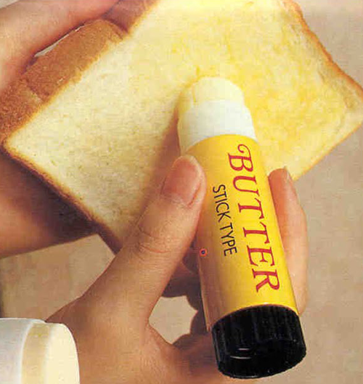

Design and Technologies Rubric |  | Year 3-4 | Student Name:
 | A | B | C | D | E
Initial Evaluation | The student has completed the evaluation with no errors in decision making | The student has completed the evaluation with one error in decision making | The student has completed the evaluation, with few errors in decision making | The student has attempted the evaluation, but incorrectly | The student has not completed the evaluation appropriately
Identification of Flaws in the Product | The student has identified a range of simple and complex flaws in the product | The student has identified two flaws in the product | The student has identified more than one basic and obvious flaw | The student has attempted to identify a flaw | The student has not identified any flaws correctly
Suggestions for Change | The student has made suggestions that demonstrate advanced thinking and reasoning, while still being effective and valid | The student has made valid and thoughtful suggestions, based off the information on the evaluation sheet | The student has made satisfactory suggestions about changes made, based off the information on the evaluation sheet | The student has attempted to make basic suggestions, but the ideas lack sense, are irrelevant, or would be ineffective | The student has made limited or no suggestions
Second Evaluation | The student has completed the evaluation with no errors, correctly and accurately showing an advanced understanding about how their changes will influence the evaluation. | The student has completed the evaluation with few errors, showing some understanding about how the changes they suggested will influence the evaluation | The student has completed the evaluation, with few errors, but has shown satisfactory understanding that their changes will influence the evaluation | The student has attempted the evaluation, but incorrectly showing limited understanding | The student has not completed the evaluation appropriately
Achievement
Comments:

Lesson One
Years 3-4 | Design and Technologies |  |  | 1 Hour | Date
Design and Technologies Knowledge and Understanding
Investigate the suitability of materials, systems, components, tools and equipment for a range of purposes (ACTDEK013)

Design and Technologies Processes and Production Skills
Evaluate design ideas, processes and solutions based on criteria for success developed with guidance and including care for the environment (ACTDEP017)
Overview  This is the first lesson in the unit “Interesting Inventions”.  Students are beginning to learn about the suitability of materials of inventions and technologies through their characteristics. |  |  | Objectives  By the end of the lesson, the students should be able to identify a range of materials by their characteristics, and be beginning to link this knowledge with suitable and unsuitable uses for the materials.
Formative assessment  At the end of this lesson, student understanding will be monitored through the completion of Worksheet 1, with questioning and discussion to also monitor verbal knowledge. |  | Summative assessment  Students will be given a basic invention. Students will evaluate the invention, using a basic evaluation sheet. The students will then circle elements and materials that should be improved to benefit the invention. Students will be required to write notes about how each element can be improved, to adhere to the evaluation sheet (such as changing the material used, removing unnecessary features, make the invention more sustainable, and improving the quality). Students should then perform another evaluation, based on their changes.
Resources needed
Glass facts:
http://www.bottlesupglass.com/wp-content/uploads/2011/08/Facts-About-Glass.pdf
Wood facts:
https://www.wood-finishes-direct.com/blog/weird-wonderful-facts-about-wood/
Cardboard facts:
http://tenrandomfacts.com/cardboard-box/
Metal facts:
http://www.encyclopedia.com/topic/Metals.aspx
Plastics facts:
http://your.caerphilly.gov.uk/kidsgogreen/fact-zone/plastic-facts
Paper facts:
http://your.caerphilly.gov.uk/kidsgogreen/fact-zone/paper-facts

Class Set of worksheet 1
IWB
A range of example materials that students are learning about (more than 1 example for each):
- Glass
- Wood
- Cardboard
- Metal
- Plastic
- Fabric
- Paper
Touchy feely box – students can feel an object, but not see it
Ascertaining prior knowledge (Warm up activity)
Have a variety of materials (listed in the resources section). Students can feel the object, and try to guess what the item is, and what it is made out of.

This leads into the main part of the lesson where the students identify features of the materials, facts, and their strengths, weaknesses, and suitability to types of inventions.

Pedagogical practices and strategies
WALT:
We Are Learning To: recognise different materials, and how suitable they are for use in different inventions
WILF
What I'm Looking For: looking for connections between materials, and how they could be effectively used
TIB
This Is Because: if you use cardboard to hold jam, it wouldn’t be effective. We need to learn how to make good choices
Overview of differentiation and individual learner attributes
For higher achieving students, setting tasks in which they must link this knowledge with practical uses – theorise how each material could be used, and justify why this is a good option

For lower achieving students, scaffolding, questioning, and support to strengthen and support learning and understanding.

Stage | Time
Warm up | 10 minutes
Questioning and activities
Put one of the objects (materials) in the feely box, and a student must identify either what the object is, or what the object is made out of.
Repeat using all materials, ensuring all students have the chance to participate.
Stage | Time
Main | 45 minutes
Questioning and activities
- Look on the above websites on the classroom IWB, identify relevant and interesting facts about the materials being analysed. Discuss information with students, extending knowledge and consolidating new learning.
- Discuss the strengths, weaknesses, facts, and features about each material.
- Begin linking these strengths and weaknesses with practical uses in technologies, products and inventions.
- Introduce worksheet 1 to the students (materials and their facts), reading through the facts, and explaining the task to students – cut out each box ad match the facts and information with the material.
- Students sort information
- Discuss answers, giving students the chance to correct their choices if needed
- Students glue the boxes into their books, making sure it is correctly sorted
- As a class, list strengths and weaknesses for each material in their books
Stage | Time
End/Review | 5 minutes
Questioning and activities
- Discuss reasonable and unreasonable uses for each material in everyday life, focusing on the characteristics, strengths, and weaknesses of each material, and how this is indicative of the use of the material.

Lesson Two
Year 3-4 | Design and Technologies | 1 hour | Date
Design and Technologies Knowledge and Understanding
Investigate the suitability of materials, systems, components, tools and equipment for a range of purposes (ACTDEK013)

Design and Technologies Processes and Production Skills
Evaluate design ideas, processes and solutions based on criteria for success developed with guidance and including care for the environment (ACTDEP017)
Overview  This is the second lesson within the unit. Students have a thorough knowledge about materials used in different technologies, and can evaluate their suitability. This lesson will introduce students to the different components of technologies/inventions, and how to recognise components, tools, equipment, and systems. Students will be expected to connect their knowledge learnt in the last lesson to the learning within this lesson. |  | Objectives  By the end of the lesson, students should be able to describe tools, components, systems, and equipment, identifying elements in pictures, and hypothesizing the roles and relationships of these elements in a range of technologies.  Students should be able to look at a technology or invention, and make a reasonable guess about how it can be used, and why it is needed.
Formative assessment  By the end of this lesson, students should be able to label a technology, identifying what it might be used for and why, how it can be used, the components of the technology.  This will be assessed through a group work task.  Students will demonstrate their ability to identify systems, components, and recognise tools and equipment. |  | Summative assessment  Students will be given a basic invention. Students will evaluate the invention, using a basic evaluation sheet. The students will then circle elements and materials that should be improved to benefit the invention. Students will be required to write notes about how each element can be improved, to adhere to the evaluation sheet (such as changing the material used, removing unnecessary features, make the invention more sustainable, and improving the quality). Students should then perform another evaluation, based on their changes.
Resources needed
Teamwork worksheet at the end of the lesson (class set)
Prior knowledge worksheet (Worksheet 2)
A selection of inventions/technologies with clear components, systems, and tools, in which students can identify the elements, and purposes of inventions.
IWB to display the inventions/technologies.
Ascertaining prior knowledge (Warm up activity)
Playing ‘around the word’. A student stands behind the desk of another student. The teacher names a material studied in the previous lesson. The first student to name either a strength, weakness, or use for that material in technologies progresses to the next seat. Repeat until all students have had the chance to participate and answer. Repeating materials, asking for more information, and requesting the specific response (weakness, for example) will challenge students and assess the knowledge and understanding of students.
Overview of differentiation and individual learner attributes
Developing higher order thinking and challenging questions for students during discussions.
Scaffold responses for lower-level students, emphasising the content of systems, components, tools, and equipment.
Carefully creating groups based on ability level and understanding to ensure students are equally contributing and learning.

Stage | Time
Warm up | 10 Minutes
Questioning and activities
Begin playing “around the world” with students.
State a material, and students can either state (and clarify which) a strength, weakness, or use for that material.
To challenge students, allocate whether they should state a strength, weakness, or use.
The first student to answer correctly moves on. Students count how many desks they moved (answers were quickest and correct). The student who moved the furthest “wins”.
Stage | Time
Main | 45 minutes
Questioning and activities
Using class discussion, complete worksheet “materials and their uses” about the possible materials used in technologies and their effectiveness.
Introduce the concept of a ‘component’ to students, using a picture of a seesaw. Identify the components, and how they affect the use. If they were dramatically changed, would it be as effective?
Introduce “systems” to students, with how the components work together to achieve a goal, and this is a system. Use the seesaw as an example.
Introduce “tools” and “equipment” to students, as how the technology/contraption can be used to achieve a goal. Link this back with the components and systems, and how the components and system enable the device to be a tool, used, and effective.

With students, create a flow chart of the learning, identifying how each new concept is connected.

(Components form a system, creating an effective tool, which is used as a tool, or equipment – collate this within a graphic organizer, timeline, or directional arrows).

Students form groups, and identify the components and systems of an item, and make a reasonable hypothesis on how the item is used, as a tool or piece of equipment. Using the worksheet “elements of an object”.
This work is completed as a group, on individual sheets of paper which is marked to assess student understanding.
Stage | Time
End/Review | 5 Minutes
Questioning and activities
Students present their item to the class, simply identifying the components, systems, tools, and equipment.

Lesson Three
Year 3-4 | Design and Technologies |  | 1 hour | Date
Design and Technologies Knowledge and Understanding
Investigate the suitability of materials, systems, components, tools and equipment for a range of purposes (ACTDEK013)

Design and Technologies Processes and Production Skills
Evaluate design ideas, processes and solutions based on criteria for success developed with guidance and including care for the environment (ACTDEP017)
Overview  This is the final lesson in this unit. Students will use their knowledge learnt in the previous lessons to evaluate technologies and inventions, based on their characteristics (materials, systems, components, tools, and equipment). |  | Objectives  By the end of the lesson, students should be able to demonstrate understanding about how to evaluate an item, using the knowledge learnt in the previous lessons. Students should be able to apply their knowledge about materials, systems, components, tools, and equipment, and make judgments about appropriateness and effectiveness. Students should be beginning to make hypotheses about how an item could be changed to make it more effective.
Formative assessment  Students will complete evaluation sheets on a range of materials. These evaluation sheets can be used as they are, or changed, by the class, or by the teacher.  Students will be expected to complete simple evaluations about a range of technologies/items.  As an extension, students can comment on the specific materials, function, and parts of the technology, their effectiveness, and hypothesise how the item could be improved (efficiency, sustainability). |  | Summative assessment  Students will be given a basic invention. Students will evaluate the invention, using a basic evaluation sheet. The students will then circle elements and materials that should be improved to benefit the invention. Students will be required to write notes about how each element can be improved, to adhere to the evaluation sheet (such as changing the material used, removing unnecessary features, make the invention more sustainable, and improving the quality). Students should then perform another evaluation, based on their changes.
Resources needed
Class set of evaluation sheets x2 (each student requires 2 evaluation sheets)
IWB
A wide range of technologies to evaluate, both as a class, and individually.
Ascertaining prior knowledge (Warm up activity)
Students are given a phrase studied previously (materials, systems, components, tool, or equipment) on a small card. A range of items/ technologies are displayed on the IWB, and students must identify the phrase on their card with the items/ technology on the IWB.
Overview of differentiation and individual learner attributes
Scaffolding learning for students, repeating information and strengthening knowledge with practical examples and active participation and discussions in class. Support learners in the activities, and work in an explicit teaching model with a gradual release of responsibility, so students can develop confidence and independence in this task. The assessment task is similar to this lesson, so it is imperative that students have sufficient knowledge to work independently.

For higher achieving students, encourage independent thought, and hypothesising about effectiveness. Encourage higher order thinking, in which students can design alternative technologies to achieve the same purpose, with effective and appropriate elements incorporated.
Stage | Time
Warm up | 10 Minutes
Questioning and activities
Each student is given a card with one of the previously learnt elements on it. Individually, students identify their element on one of the items/technologies displayed on the board. Students may be asked to justify their response, and may be asked further questions to elaborate on their knowledge.
Stage | Time
Main | 45 minutes
Questioning and activities
Introduce the evaluation template
Optional- With students, alter the evaluation sheet to fit with the focuses and knowledges of the students within the class.
Explicitly investigate the evaluation sheet. Discuss what each criterion is, and answer questions that students may have.
Demonstrate completing the evaluation to students, discussing thinking and reasoning.
As a class, complete another evaluation on an item, discussing the elements, hypothesizing the use and purpose, sustainability, and the reasonableness/effectiveness.
In buddies, students complete another evaluation, and the results are discussed as a class.
Students complete an evaluation individually, which is checked by the teacher.
Students identify elements of the technology (systems, components, materials, tools, equipment), and comment on the effectiveness/sustainability/reasonableness.
As a class, discuss what changes could be made to make the technology fit to the evaluation effectively.
Stage | Time
End/Review | 5 minutes
Questioning and activities
Continue the discussion about the possible changes that could be made, constantly scaffolding and linking the ideas and discussion back to the sustainability, materials, components, systems, tools, and equipment.

Materials and Facts (Cut out and match)
Glass | Made from processed wood  Is a form of sturdy paper  Not waterproof  Low cost  Has lots of uses
Wood | Very commonly used  Very light  Used for a variety of purposes  Man made from oil  Recycling this material is very important
Cardboard | Made from processed trees and wood, with chemicals  Not waterproof  Man made  Cannot be ‘broken’, but can be easily ripped  Cheap and easily accessible
Metal | Can break or smash  Made from sand, soda ash, and limestone  A wide range of uses  Easy to clean and waterproof  Can be used for aesthetics and food containers
Plastic | Woven  Made from both natural and man made materials  Very flexible  Cannot be ‘broken’, but can be ripped and torn  Commonly used for clothing
Fabric | A naturally occurring material  Sourced from trees  Strong, and does not break easily  Can be quite heavy  Generally waterproof
Paper | Comes in a variety of types  Sometimes naturally occurring, found in rocks  Many are strong, shiny, and hard  Does not break easily  Commonly used for large machinery

Materials and Their Uses (Cut out and match)

Glass | 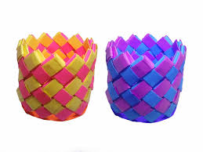
Wood | 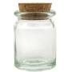
Cardboard | 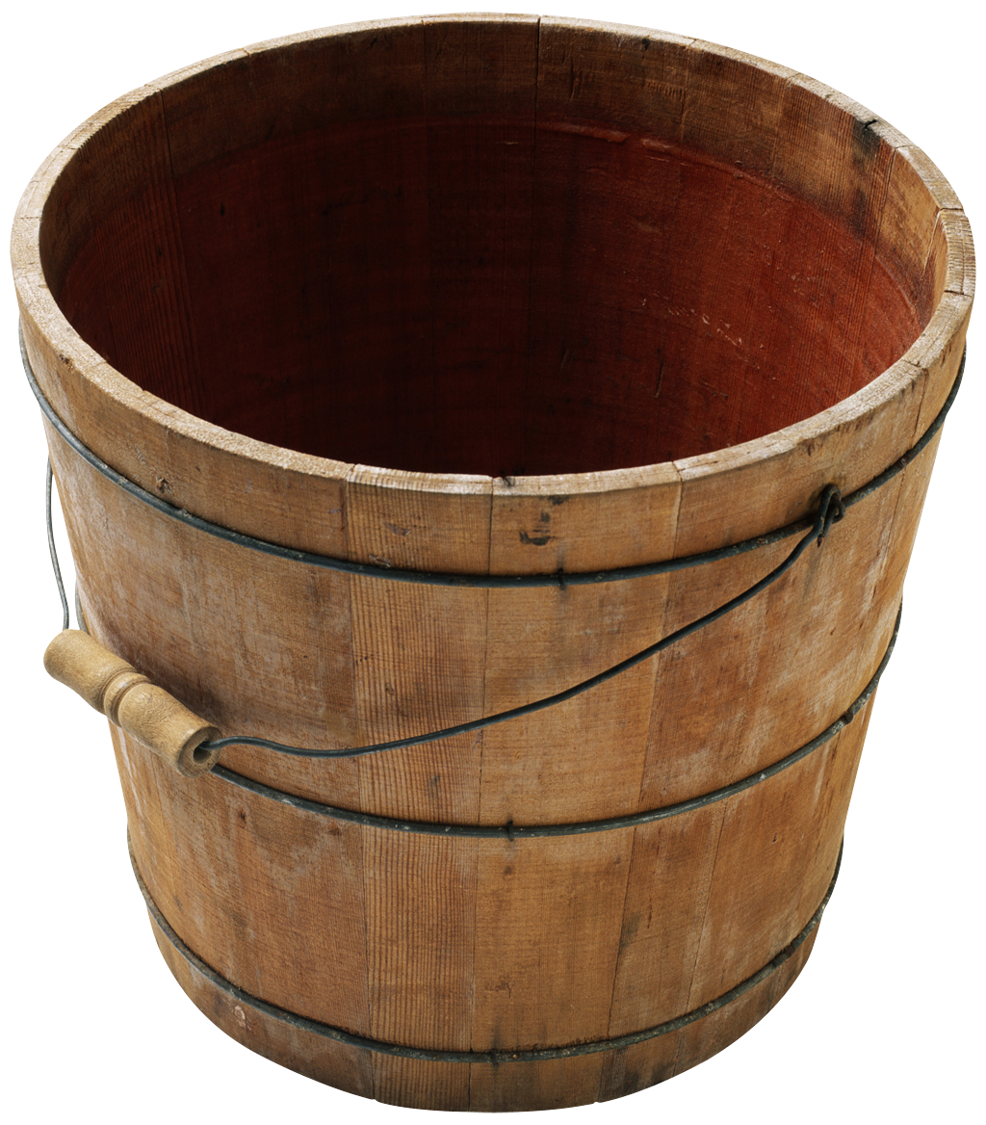
Metal | 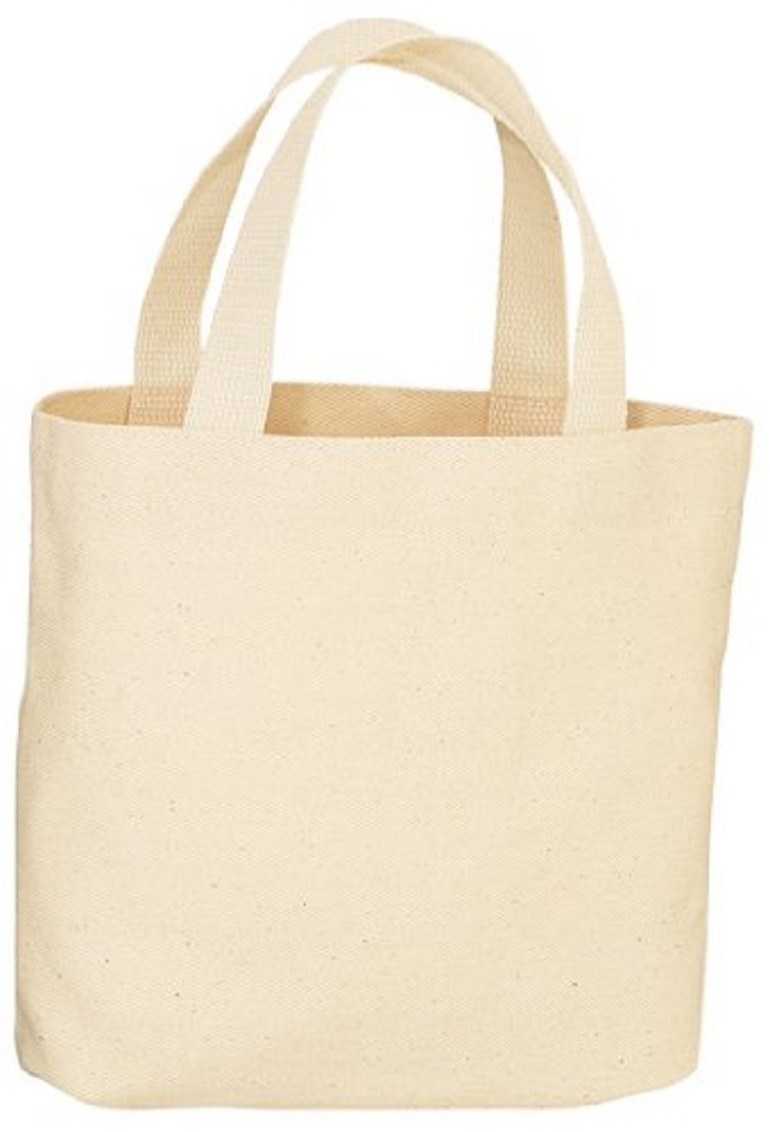
Plastic | 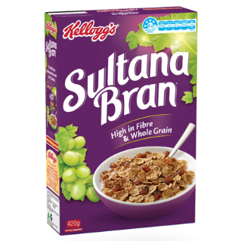
Fabric | 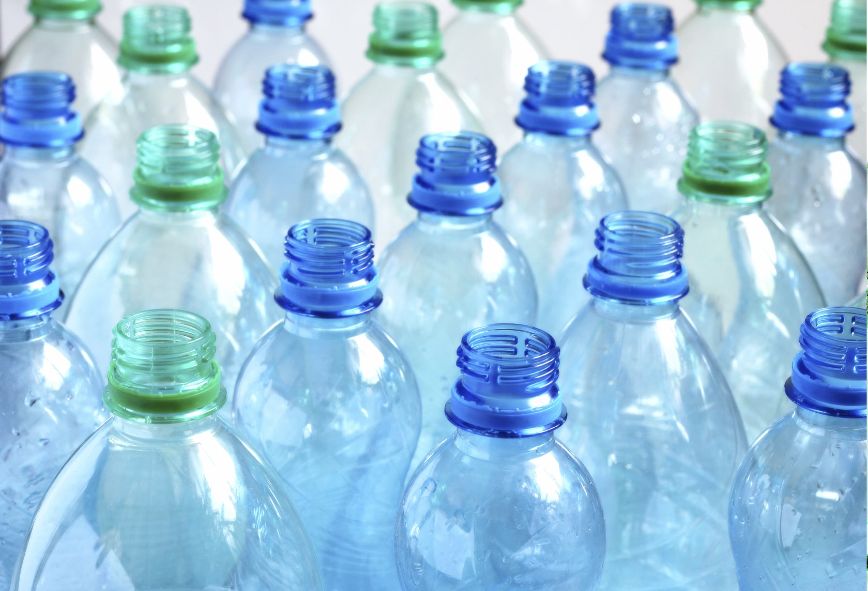
Paper | 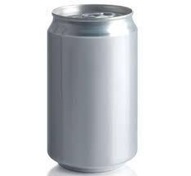

Elements of an Object
Write in your book

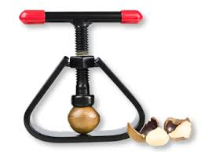
Find:
Material/s
Systems
Components
Tools
Equipment

Discuss
What does this do?
How does it work?
Do you think it works well?
Is this sustainable?
Is this made from sustainable materials?
How could this be made better?

Evaluation Worksheet
Complete in your book
Evaluation: Item 1
 | Yes | No
Functional Qualities
Does it achieve the purpose? Does it make sense? Is it easy for people to use? Will people want to use it? Is it needed?
Aesthetic Qualities
Is it neat? When people see it, will they be interested? Will people want to buy it? Does the design fit with the purpose? Are the colours suitable?
Sustainability
Is it made from sustainable products? Can it be used more than once? Is it sturdy and strong? Is it recyclable?
Waste
Does the production of this resource create a large amount of waste? Will this resource create waste? Will this resource become waste when it cannot be used anymore?

 | Yes | No
Functional Qualities
Does it achieve the purpose? Does it make sense? Is it easy for people to use? Will people want to use it? Is it needed?
Aesthetic Qualities
Is it neat? When people see it, will they be interested? Will people want to buy it? Does the design fit with the purpose? Are the colours suitable?
Sustainability
Is it made from sustainable products? Can it be used more than once? Is it sturdy and strong? Is it recyclable?
Waste
Does the production of this resource create a large amount of waste? Will this resource create waste? Will this resource become waste when it cannot be used anymore?
Evaluation: Item 2

