Materials and Facts (Cut out and match)
Glass | Made from processed wood  Is a form of sturdy paper  Not waterproof  Low cost  Has lots of uses
Wood | Very commonly used  Very light  Used for a variety of purposes  Man made from oil  Recycling this material is very important
Cardboard | Made from processed trees and wood, with chemicals  Not waterproof  Man made  Cannot be ‘broken’, but can be easily ripped  Cheap and easily accessible
Metal | Can break or smash  Made from sand, soda ash, and limestone  A wide range of uses  Easy to clean and waterproof  Can be used for aesthetics and food containers
Plastic | Woven  Made from both natural and man made materials  Very flexible  Cannot be ‘broken’, but can be ripped and torn  Commonly used for clothing
Fabric | A naturally occurring material  Sourced from trees  Strong, and does not break easily  Can be quite heavy  Generally waterproof
Paper | Comes in a variety of types  Sometimes naturally occurring, found in rocks  Many are strong, shiny, and hard  Does not break easily  Commonly used for large machinery

Materials and Their Uses (Cut out and match)

Glass | 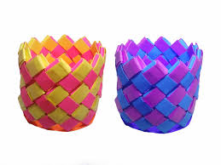
Wood | 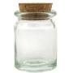
Cardboard | 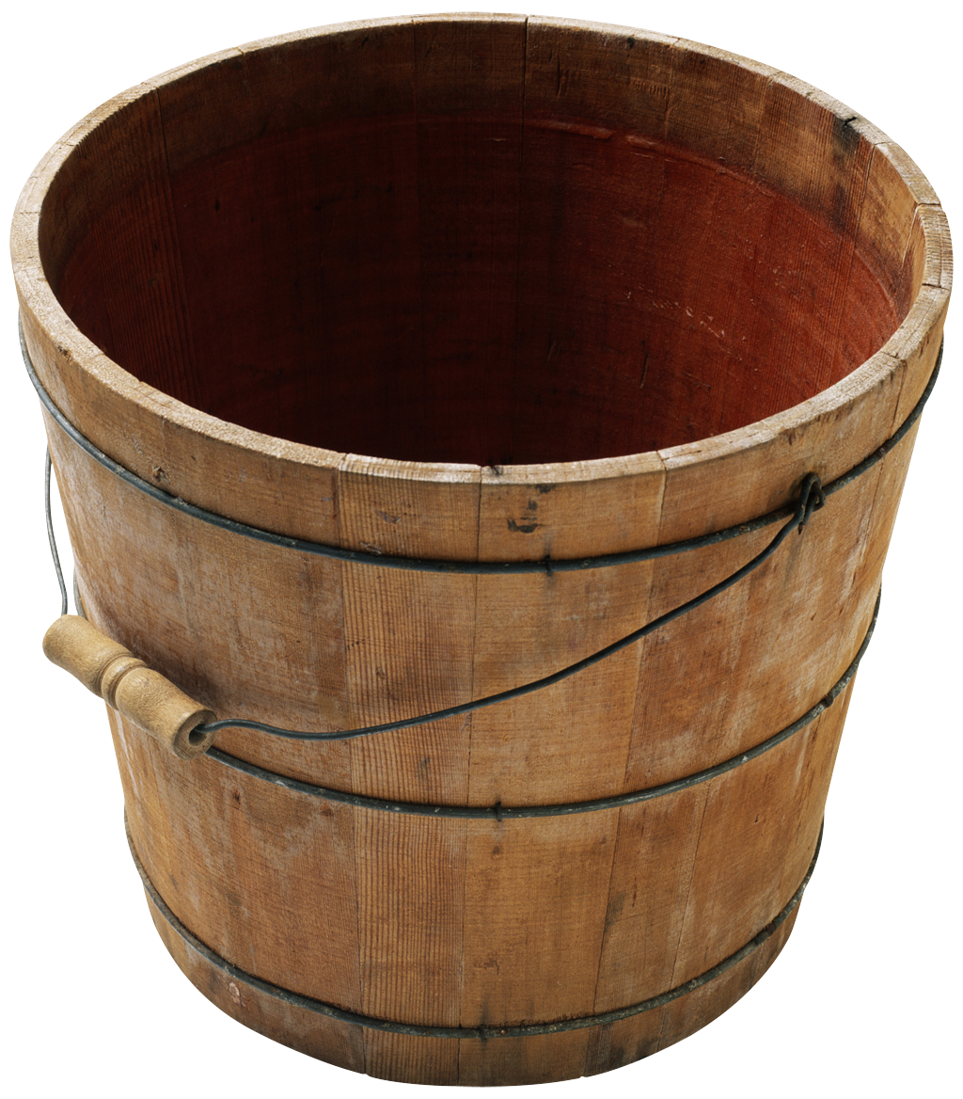
Metal | 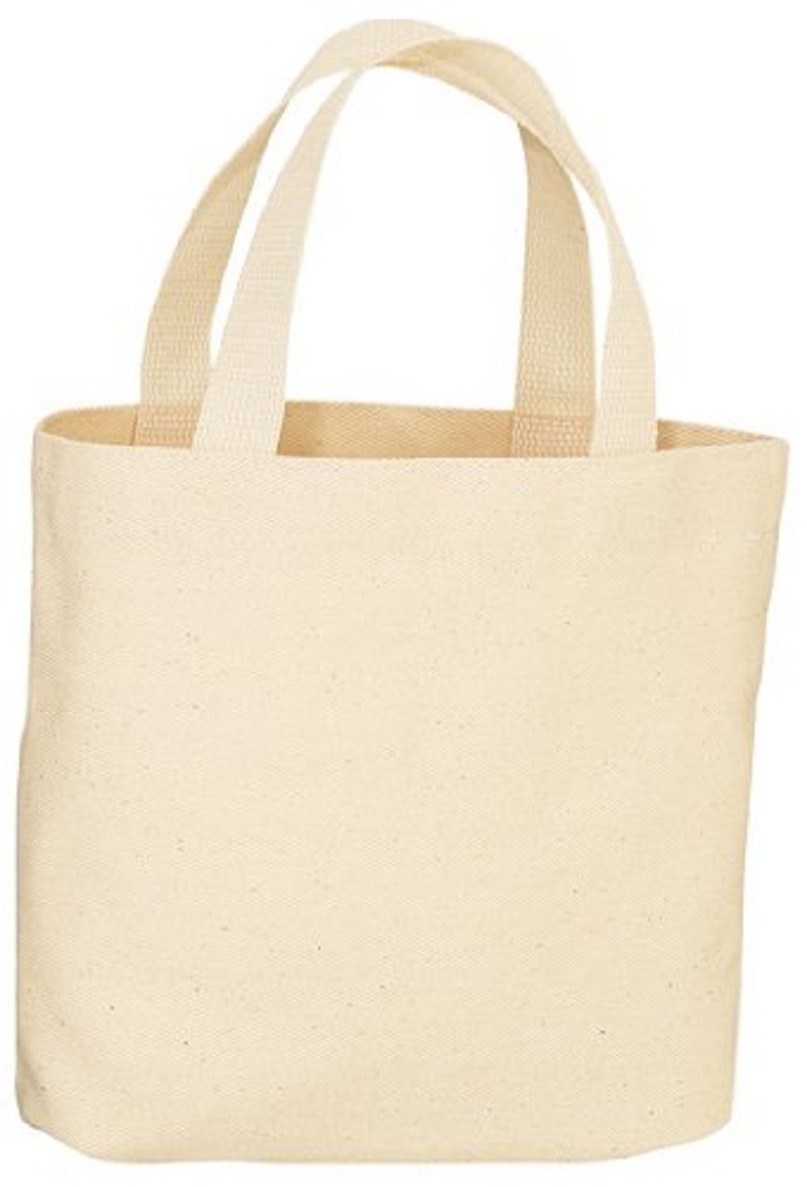
Plastic | 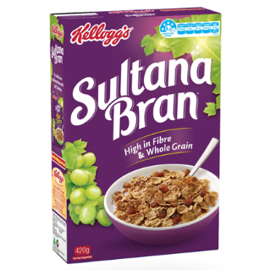
Fabric | 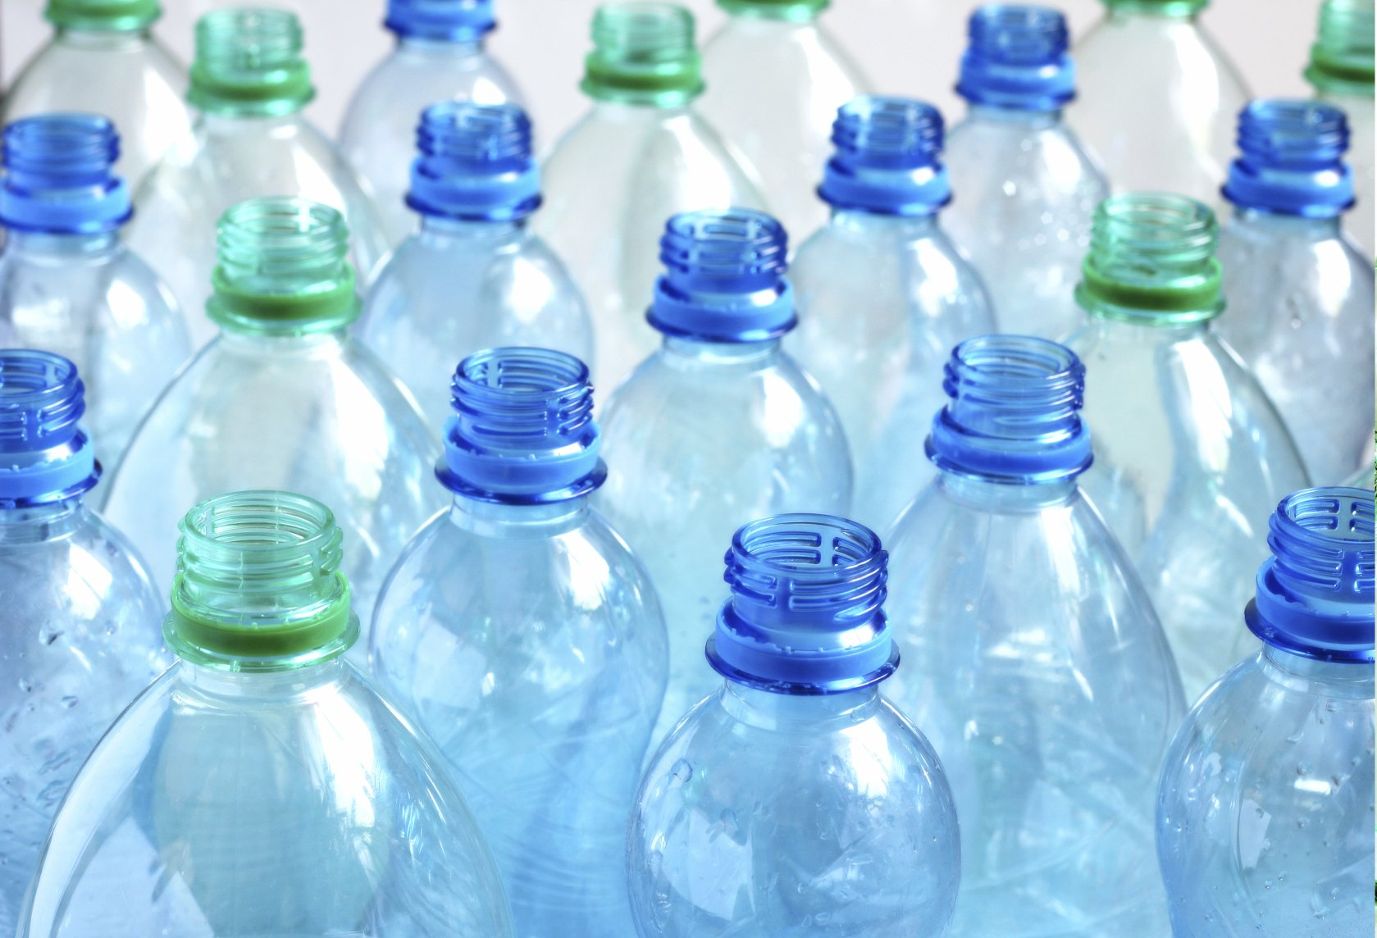
Paper | 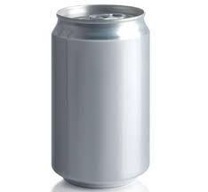

Elements of an Object
Write in your book

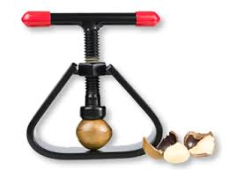
Find:
Material/s
Systems
Components
Tools
Equipment

Discuss
What does this do?
How does it work?
Do you think it works well?
Is this sustainable?
Is this made from sustainable materials?
How could this be made better?

Evaluation Worksheet
Complete in your book
Evaluation: Item 1

 | Yes | No
Functional Qualities
Does it achieve the purpose? Does it make sense? Is it easy for people to use? Will people want to use it? Is it needed?
Aesthetic Qualities
Is it neat? When people see it, will they be interested? Will people want to buy it? Does the design fit with the purpose? Are the colours suitable?
Sustainability
Is it made from sustainable products? Can it be used more than once? Is it sturdy and strong? Is it recyclable?
Waste
Does the production of this resource create a large amount of waste? Will this resource create waste? Will this resource become waste when it cannot be used anymore?

 | Yes | No
Functional Qualities
Does it achieve the purpose? Does it make sense? Is it easy for people to use? Will people want to use it? Is it needed?
Aesthetic Qualities
Is it neat? When people see it, will they be interested? Will people want to buy it? Does the design fit with the purpose? Are the colours suitable?
Sustainability
Is it made from sustainable products? Can it be used more than once? Is it sturdy and strong? Is it recyclable?
Waste
Does the production of this resource create a large amount of waste? Will this resource create waste? Will this resource become waste when it cannot be used anymore?
Evaluation: Item 2

