Design and Technologies  Assessment 1 Task Sheet | Name:
Due Date:
Your Task: Your task is to evaluate an invention, using the worksheet you used in the last lesson. You must then use the evaluation sheet to circle the parts of the invention that could be improved. Use your knowledge and imagination to suggest alternatives. Then, use the evaluation sheet to evaluate the changes that you made.
Steps
- Look at the invention and think about the features and how effective it is
- Complete the evaluation page about the invention
- Circle what could be changed to make it better or more sustainable. Use your evaluation sheet to give you ideas about what to change
- Write how you would change those things – what would you use to change what you’ve circled?
- Complete a second evaluation sheet, based on the changes you made
The Invention
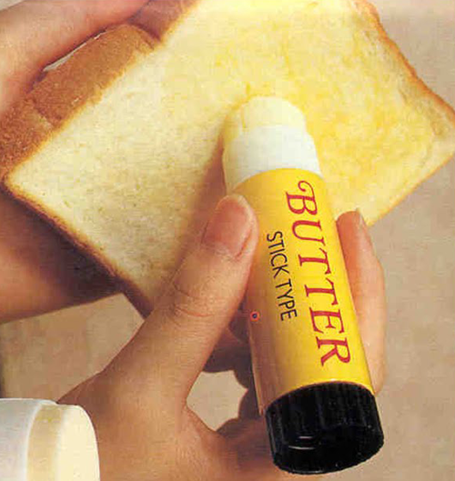

Design and Technologies Rubric |  | Year 3-4 | Student Name:
 | A | B | C | D | E
Initial Evaluation | The student has completed the evaluation with no errors in decision making | The student has completed the evaluation with one error in decision making | The student has completed the evaluation, with few errors in decision making | The student has attempted the evaluation, but incorrectly | The student has not completed the evaluation appropriately
Identification of Flaws in the Product | The student has identified a range of simple and complex flaws in the product | The student has identified two flaws in the product | The student has identified more than one basic and obvious flaw | The student has attempted to identify a flaw | The student has not identified any flaws correctly
Suggestions for Change | The student has made suggestions that demonstrate advanced thinking and reasoning, while still being effective and valid | The student has made valid and thoughtful suggestions, based off the information on the evaluation sheet | The student has made satisfactory suggestions about changes made, based off the information on the evaluation sheet | The student has attempted to make basic suggestions, but the ideas lack sense, are irrelevant, or would be ineffective | The student has made limited or no suggestions
Second Evaluation | The student has completed the evaluation with no errors, correctly and accurately showing an advanced understanding about how their changes will influence the evaluation. | The student has completed the evaluation with few errors, showing some understanding about how the changes they suggested will influence the evaluation | The student has completed the evaluation, with few errors, but has shown satisfactory understanding that their changes will influence the evaluation | The student has attempted the evaluation, but incorrectly showing limited understanding | The student has not completed the evaluation appropriately
Achievement
Comments:

